|  |
| --- |
| H48W35 HND Software Development |
| User Documentation |
| Simply Rugby Prototype |

|  |
| --- |
| David Kilpatrick  1867240 |

Welcome to Simply Rugby Skill Tracking prototype. The program has been designed as a skill tracking and performance reference demonstration tool for rugby coaches. Using this program will make recording player details of these areas quick and easy. With all the Player Profiles being constantly stored, they can be viewed or altered anytime. This document should give you all the information and explanations you will need to get the most out of the program.

All User Accounts, Coaches and Players are generated by the program. This allows you to experience the Skill Tracking system independently from a full program. All these generated items are in lists provided with this document.

A coach manages one and only one squad at a set age bracket. The User Account allows access to see and alter Player Profiles of the squad they manage only. For example, the Senior coach only has access to the Senior squad so can not search for, view or alter players outside of their given squad at that age bracket.

The document is split into a few parts. First being a screen by screen information guide, second a *How To* section and lastly User Accounts and Player listings. Lets get started.

|  |  |
| --- | --- |
| Screen Information  How To  Listings | Page 2  Page 10  Page 25 |

Screen Information Guide

|  |  |
| --- | --- |
| * Title Screen * Login Screen * Main Menu Screen * Player Profile Select Screen * Player Profile Screen * Score Card * Screen Hints | Page 3  Page 4  Page 5  Page 6  Page 7  Page 8  Page 9 |

Title Screen

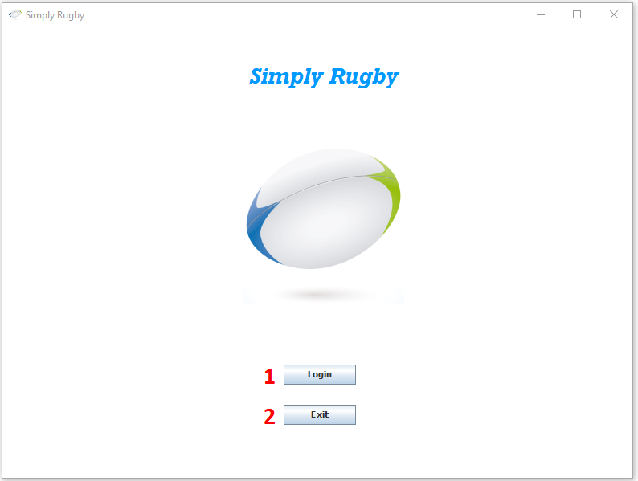

On program start up this will be the first screen seen.

1. Login Button – Click this to progress to the Login Screen.
2. Exit Button – Click this to shut down the program.

Login Screen

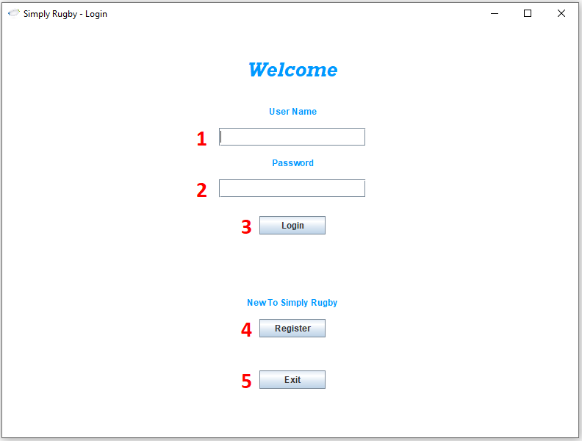

This is where login into the program happens. Look at the User Account List provided with this document to get a Username and Password.

1. Login Box – Type your User Name here.
2. Password Box – Type your Password here.
3. Login Button – Click this to attempt a login using the account details you provided.
4. Register Button – Not part of this build.
5. Exit Button - Click this to shut down the program.

Main Menu Screen

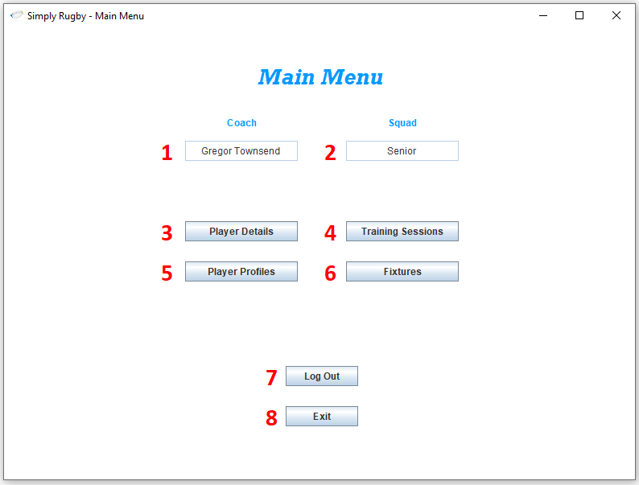

The main hub of the program. Allows navigation to all the other areas. This prototype only has the Player Profiles function currently.

1. Coach Box - This is the current User/Coach logged into the program.
2. Squad Box – This is the squad the current User/Coach is managing.
3. Player Details Button - Not part of this build.
4. Training Sessions Button – Not part of this build.
5. Player Profiles Button – Click this to progress to Player Profile Selection.
6. Fixtures Button - Not part of this build.
7. Log Out - Click this to Log Out of the program and return to the Title Screen.
8. Exit Button - Click this to shut down the program.

Player Profile Select Screen

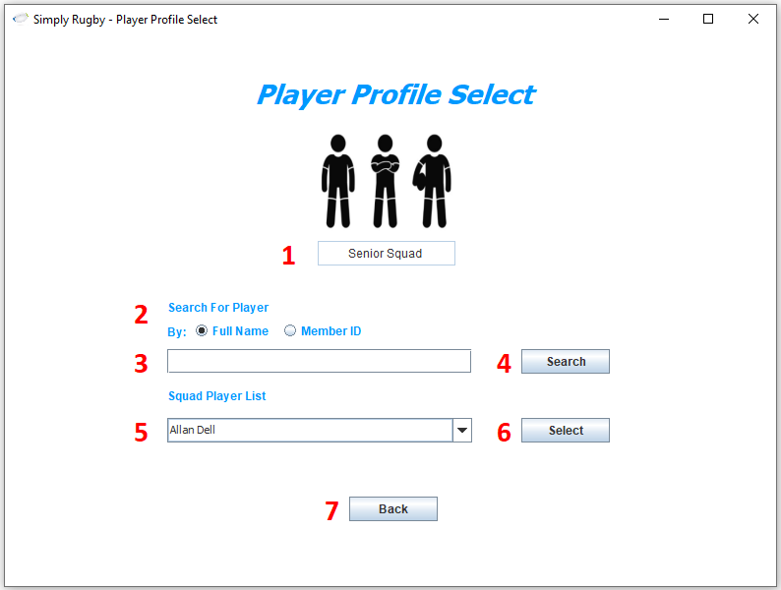

Screen to allow Player Profile selection by Name, MemberID or squad list. A successful selection brings up the Player Profile of that player. Look at the player list provided for Player Profiles to select from.

1. Squad Box - This is the squad the current User/Coach is managing and the squad a Profile selection will be from.
2. Search Criteria – Use the Radio buttons to set what type of search will be done.
3. Search Box – Type your player search here.
4. Search Button – Click this to search for the player you want by the set criteria.
5. Squad List Box – Select a player from the list.
6. Select Button – Click this to select the player from the Squad List Box.
7. Back Button – Click this to return to the Main Menu Screen.

Player Profile Screen

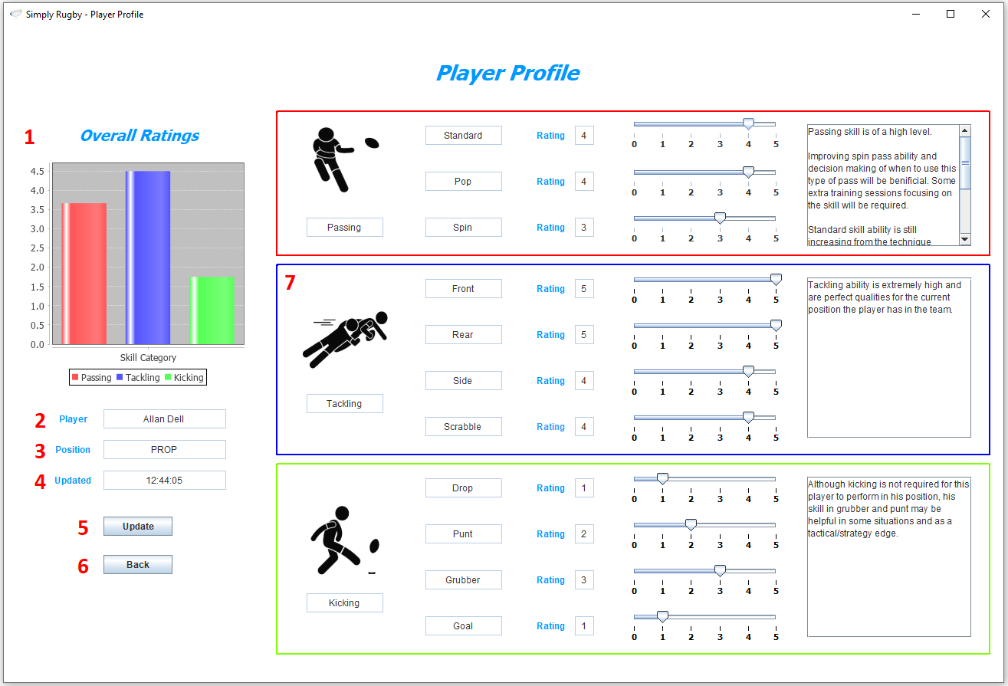

Player Profile Screen displaying the player that has been selected. Here you can view all their current playing position, skill ratings and category comments. Skill ratings and comments can be altered to your liking to reflect current player performance and ability.

1. Overall Ratings Chart – Displays the average rating of the skills for each colour coded Score Card.
2. Player Box – This is the name of the player that the profile belongs to.
3. Position Box – This is the current playing position of the player.
4. Updated Box – This is the Date/Time the profile was last changed.
5. Update Button – Click this to apply any change made to the profile to record.
6. Back Button – Click this button to return to the Player Profile Select Screen.
7. Score Card – Each colour coded Score Card contains the information for one category.

Score Card

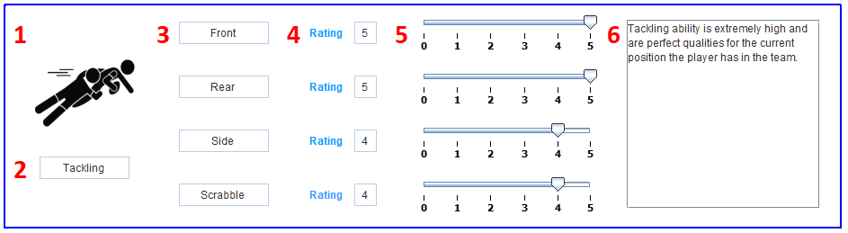

This is the Score Card. Each has a name, image and colour to represent a category. A Score Card contains the skill ratings of skills and comment for a category.

1. Category Image – Image of category.
2. Category Box – Name of the category.
3. Skill Box – Name of the skill.
4. Rating Box – Current rating for the skill.
5. Rating Slider – Change this to the new skill rating.
6. Category Comment – Comment for current category.

Screen Hints

If ever having trouble remembering how to do something or what it does, just hold the mouse cursor over a screen element to get a tooltip.

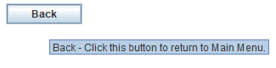

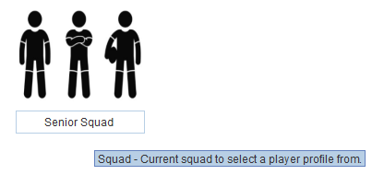

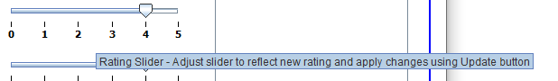

How To

Below is a list of walkthroughs of questions you may have.

|  |  |
| --- | --- |
| * Login * Exit * Log Out * Search For Player By Name * Search For Player By MemberID * Select A Player From Squad List * Update A Category Comment * Update A Skill Rating | Page 11  Page 13  Page 14  Page 15  Page 17  Page 19  Page 20  Page 23 |

Login

To login to the program make your way to the Login Screen.

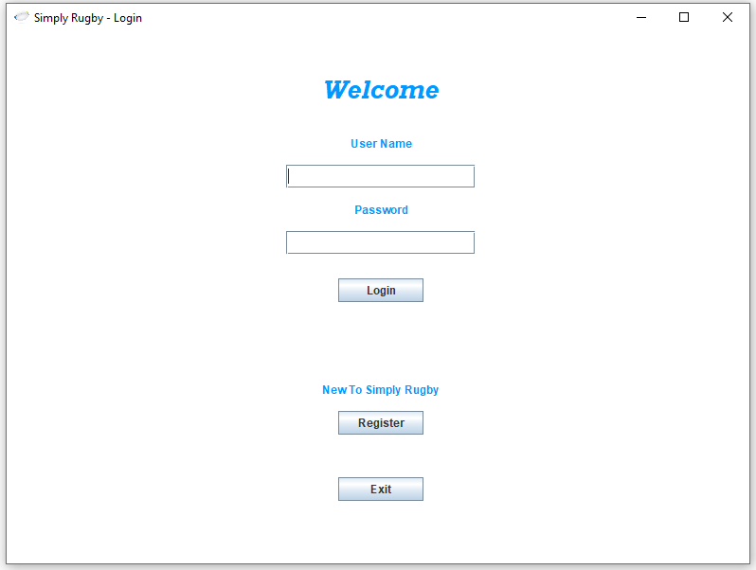

Next get your account details from the User Account List. Lets pick the first on the list as an example.

User Name: online Password: pass

Enter the details in the correct boxes.

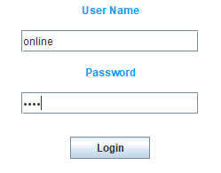

Then click Login. Don’t worry if you make a mistake. If you do, the program will give you feedback and allow you to retry. Feedback should narrow down what you need to fix to login successfully.

No details entered. Just add some details to the input boxes.

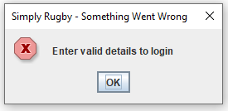

Wrong details entered. The details entered are not of a valid account.

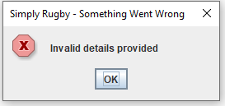

Be careful with the details you enter as they must be exact to what is shown in the User Account list.

A successful Login attempt will display the Main Menu Screen.

Exit

Exiting the program can be done at anytime by clicking the X in the top right of the program screen,

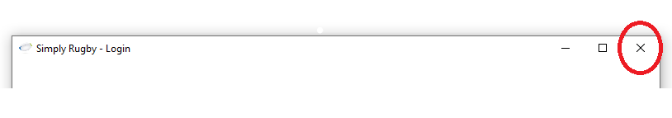

or by clicking the Exit Button.

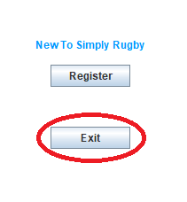

Be careful though as any Player Profile changes not updated will be lost.

Log Out

Logging out of the program can be done by clicking the Log Out Button on the Main Menu Screen.

This will log out the current user and return the program to the Title Screen.

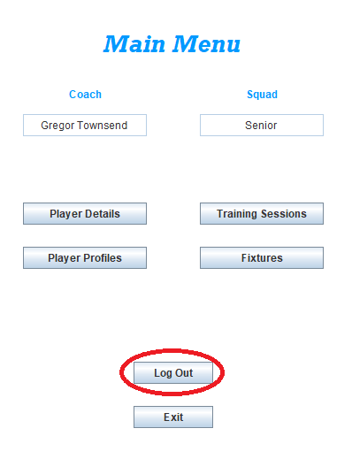

Once the button is clicked the program will ask for conformation, just incase you clicked in error.

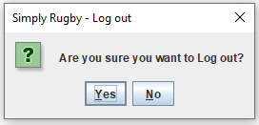

Yes to log out, No to stay logged in and continue using the program.

Search For Player Profile By Name

To search for a Player Profile by Name, make your way to the Player Profile Select Screen.

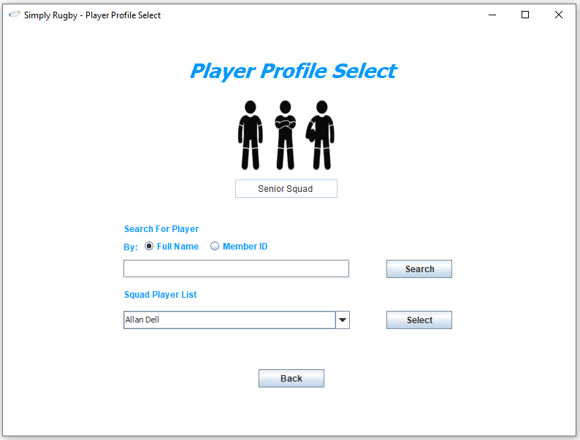

Next get your player from the Player List that the current user/coach is managing. Lets pick the first on the list as an example.

Player Name: Allan Dell

Enter the details in the correct box.

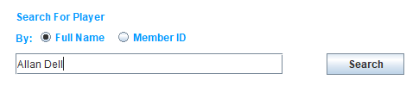

Next select the criteria to search by, we want Full Name and this is the default selection.

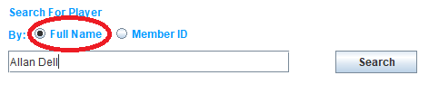

Then click Search. Don’t worry if you make a mistake. If you do, the program will give you feedback and allow you to retry. Feedback should narrow down what you need to search successfully.

No details entered. Just add some details to the input boxes.

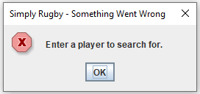

Wrong details entered. The details entered are not of a valid player.

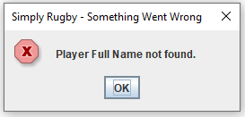

The program is more forgiving of inputs here than during login attempts. Try searching for aLLaN dELL and see what happens.

A successful search will display the Player Profile Screen with the details of your searched for player.

Search For Player By MemberID

To search for a Player Profile by MemberID, make your way to the Player Profile Select Screen.



Next get your player from the Player List that the current user/coach is managing. Lets pick the first on the list as an example.

Player MemberID: Player2

Enter the details in the correct box.

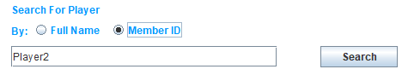

Next select the criteria to search by, we want MemberID.

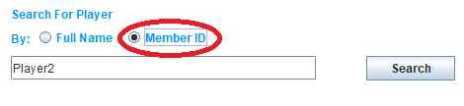

Then click Search. Don’t worry if you make a mistake. If you do, the program will give you feedback and allow you to retry. Feedback should narrow down what you need to search successfully.

No details entered. Just add some details to the input boxes.

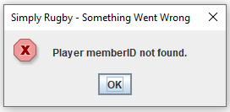

Wrong details entered. The details entered are not of a valid player.



The program is more forgiving of inputs here than during login attempts. Try searching for pLAyeR2 and see what happens.

A successful search will display the Player Profile Screen with the details of your searched for player.

Select A Player From Squad List.

To select a Player Profile from the current squad list, make your way to the Player Profile Select Screen.



Next use the drop down menu to select which player profile you want to see that the current user/coach is managing.

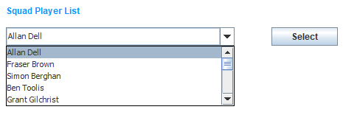

Click the Select Button and the Player Profile of your selected player will be shown.

Update A Category Comment

To update a category comment, make your way to the Player Profile Screen.

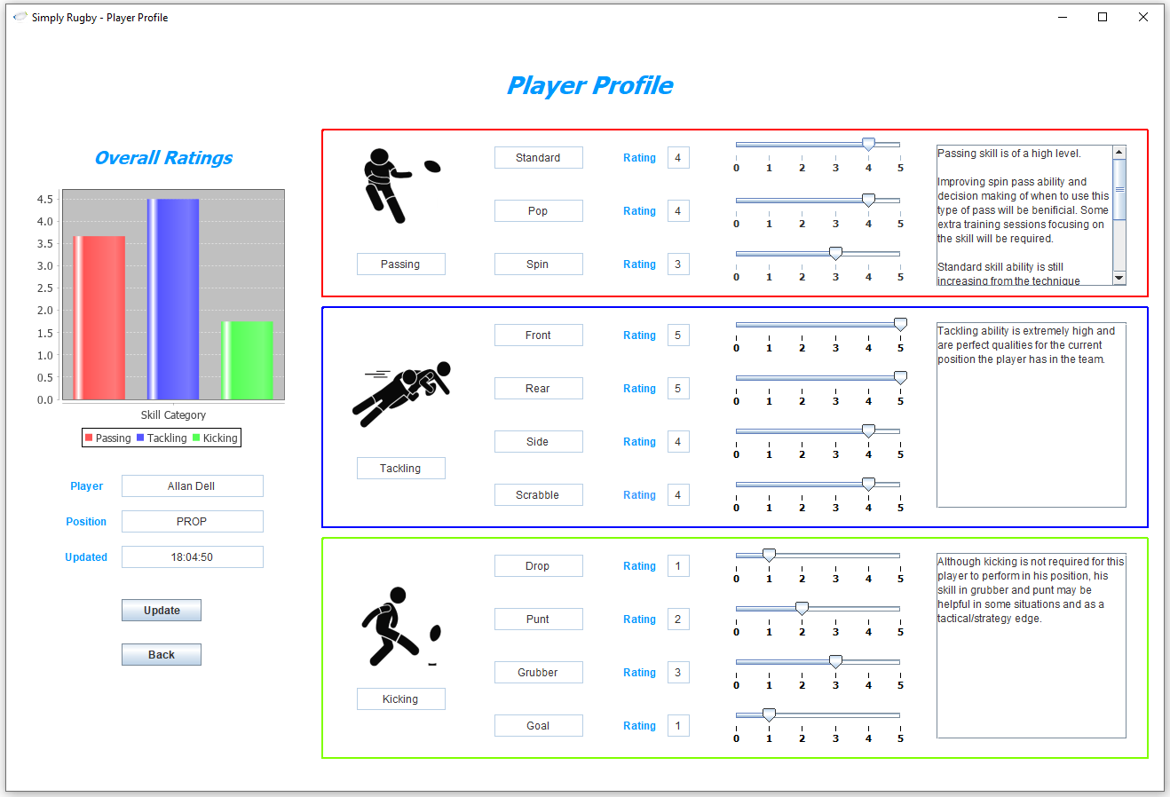

The current category comments are shown down the right hand side inside a Score Card.

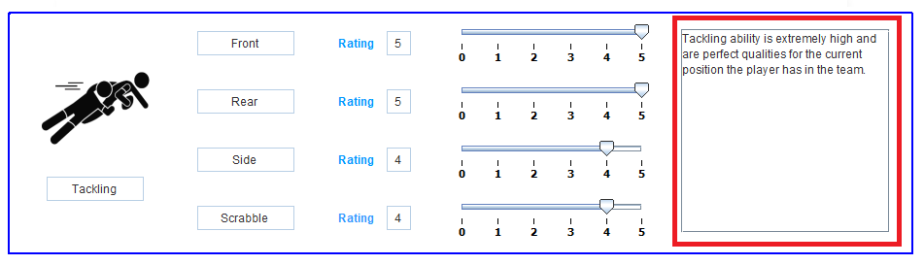

Category comments can be changed at any time.

Adding to or changing the content will be the comment taken as the new Category Comment.

Current:

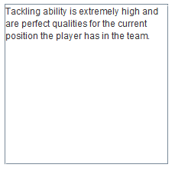

Changed:

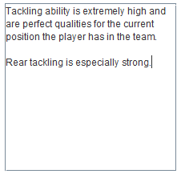

Once happy with the comment click the Update Button.

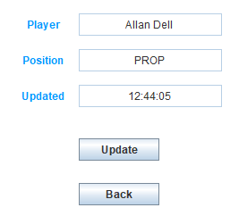

This will start the update process and the program will ask for conformation, just incase you clicked in error.

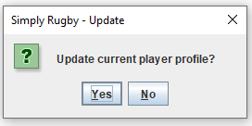

Yes to update the profile, No to cancel the update.

A successful update will change the current Player details to the details displayed on the Player Profile Screen. The hard copy of the details will also be changed so that the information is kept in sync and the program information current after program shut down. When the program returns to the Player Profile Screen the details will now be that of which you set. The Updated Box will also be a new value to reflect time of update.

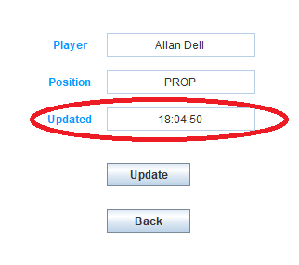

A different window message that might be seen during the update process is the Continue Update window even though a comment box does not contain a comment.

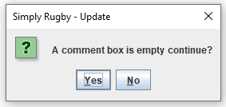

Yes to continue update, No to cancel. Just a check to make sure you realise the comments are not all complete.

Update A Skill Rating

To update a skill rating, make your way to the Player Profile Screen.



Skill ratings are displayed within a Score Card.

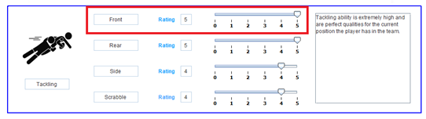

Each skill has a Name, current Rating and Slider Bar.

Moving the Slider Bar to a different number will be value taken as the new Skill Rating.

Current:



Changed:



Once happy with the Skill Rating click the Update Button.

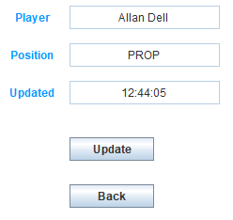

This will start the update process and the program will ask for conformation, just incase you clicked in error.



Yes to update the profile, No to cancel the update.

A successful update will change the current Player details to the details displayed on the Player Profile Screen. The hard copy of the details will also be changed so that the information is kept in sync and the program information current after program shut down. When the program returns to the Player Profile Screen the details will now be that of which you set. The Updated Box will also be a new value to reflect time of update.

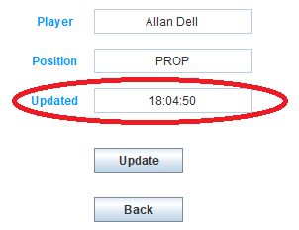

Listings

User Accounts

|  |  |  |  |
| --- | --- | --- | --- |
| **Coach** | **Squad** | **User Name** | **Password** |
|  |  |  |  |
| Gregor Townsend | Senior | online | pass |
| Eddie Jones | U16 | email | access |
| Warren Gatland | U13 | internet | valid |
|  |  |  |  |

Players

Senior Squad

|  |  |  |  |
| --- | --- | --- | --- |
| **Player** | **MemberID** | **Squad** | **Squad Coach** |
|  |  |  |  |
| Allan Dell | Player2 | Senior | Gregor Townsend |
| Fraser Brown | Player3 | Senior | Gregor Townsend |
| Simon Berghan | Player4 | Senior | Gregor Townsend |
| Ben Toolis | Player5 | Senior | Gregor Townsend |
| Grant Gilchrist | Player6 | Senior | Gregor Townsend |
| Magnus Bradbury | Player7 | Senior | Gregor Townsend |
| Hamish Watson | Player8 | Senior | Gregor Townsend |
| Luke Crosbie | Player9 | Senior | Gregor Townsend |
| Byron Mcguigan | Player10 | Senior | Gregor Townsend |
| Ali Price | Player11 | Senior | Gregor Townsend |
| Adam Hastings | Player12 | Senior | Gregor Townsend |
| Chris Harris | Player13 | Senior | Gregor Townsend |
| Matt Scott | Player14 | Senior | Gregor Townsend |
| Kyle Steyn | Player15 | Senior | Gregor Townsend |
| Blair Kinghorn | Player16 | Senior | Gregor Townsend |
|  |  |  |  |

U16 Squad

|  |  |  |  |
| --- | --- | --- | --- |
| **Player** | **MemberID** | **Squad** | **Squad Coach** |
|  |  |  |  |
| Owen Farrell | Player18 | U16 | Eddie Jones |
| Tom Dunn | Player19 | U16 | Eddie Jones |
| Jonny May | Player20 | U16 | Eddie Jones |
|  |  |  |  |

U13 Squad

|  |  |  |  |
| --- | --- | --- | --- |
| **Player** | **MemberID** | **Squad** | **Squad Coach** |
|  |  |  |  |
| Dan Biggar | Player22 | U13 | Warren Gatland |
| Elliot Dee | Player23 | U13 | Warren Gatland |
| Josh Adams | Player24 | U13 | Warren Gatland |
|  |  |  |  |